Университет ИТМО, факультет программной инженерии и компьютерной техники
Двухнедельная отчётная работа по «Информатике»: аннотация к статье

Дата прошедшей лекции | Номер прошедшей лекции | Название статьи/главы книги/видеолекции | Дата публикации (не старше 2022 года) | Размер статьи (от 400 слов) | Дата сдачи
10.09.2025 | 1 | Decimal Versus Binary Representation of Numbers in Computers | 1.10.2022 | 4424 | 24.09.2025
24.09.2025 | 2 | Data Compression Technology Explained: Balance between Costs & Performance | 8.11.2022 | 2562 | 08.10.2025
08.10.2025 | 3 | Mastering Regular Expressions with Python | 01.08.2023 | 1711 | 05.11.2025
 | 4
 | 5
 | 6
 | 7

Выполнил(а) Цэрэндорж Ариунбат , № группы P3113 , оценка
^{Фамилия И.О. студента} ^{не заполнять}
Прямая полная ссылка на источник или сокращённая ссылка (bit.ly, tr.im и т.п.)
https://www.kdnuggets.com/2023/08/mastering-regular-expressions-python.html
Теги, ключевые слова или словосочетания (минимум три слова)
Regular expressions in Python, Pattern matching in strings, Meta characters in regex
Перечень фактов, упомянутых в статье (минимум четыре пункта)
- Python provides full support for regular expressions through the built-in re module.
- Meta characters such as . , ^, $, *, +, ?, {}, and [] give regular expressions their power.
- Character sets written in square brackets like [a-zA-Z] help match a range of letters or digits at once, while predefined character classes like \d, \w, and \s simplify matching digits, word characters, and spaces.
- Common real life applications of regular expressions include tasks such as validation of emails, phone numbers, IP addresses, and URLs. This article provides python code examples for each of these.
- The author advises building regex patterns step by step, testing each part carefully instead of writing one long, complicated expression. This approach makes patterns more reliable and easier to understand.
- Online regex testing tools like Regex101 or RegExr are suggested as practical ways to experiment with and debug expressions visually.
Позитивные следствия и/или достоинства описанной в статье технологии (минимум три пункта)
- Regular expressions make it possible to search and extract information from large amounts of text quickly and precisely.
- Regular expressions help automate repetitive text-processing tasks.
- Regex patterns allow developers to validate formats like emails, phone numbers, and URLs which prevents input errors and improving data quality.
- Since python includes the re module by default it’s easy to implement regular expressions without external libraries
Негативные следствия и/или недостатки описанной в статье технологии (минимум три пункта)
- Regular expressions can be difficult to understand for beginners because their syntax is dense and filled with abstract symbols
- Complex regex patterns can be hard to read, even for experienced developers
- A single misplaced symbol can completely change the meaning of a pattern which then leads to the output being completely different of what the user might have expected.
Ваши замечания, пожелания преподавателю или анекдот о программистах
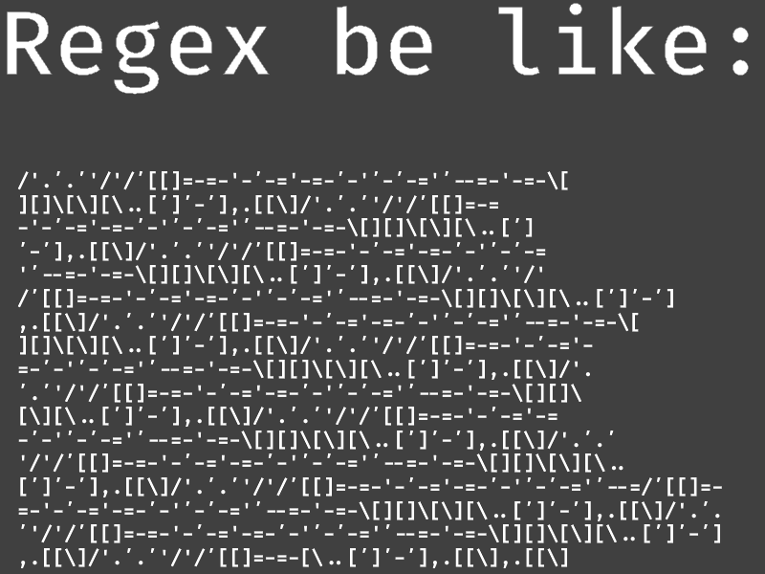

Наличие этой графы не влияет на оценку

